32nd Clophill AC Double WA 720 Weekend (Autumn)
on
Saturday 19th and Sunday 20th September 2026

To be held at Braziers Field, Kiln Lane, Clophill, Bedfordshire
(to the rear of Clophill Village Hall, MK45 4BX)
what3words Location – target.spells.ignore
World Record Status
Field Open 07:00, Registration From 07:45, Assembly 08:30, Practice 08:45 – 09:30, Competition Start 09:30

You must adhere to all guidance or entry will be refused and no refund given

Rounds | Double WA 720 each day – World Record Status. (Sorry, no single round entries)  Recurve – 2 x 6 dozen arrows at 70m on 122cm Face (U18 & Master at 60m & U15 at 50m on 122cm Face)  Barebow– 2 x 6 dozen arrows at 50m on 122cm Face  Compound – 2 x 6 dozen arrows at 50m on 80cm Face  Longbow – 2 x 6 dozen arrows at 70m on 122cm Face (U18 & Master at 60m & U15 at 50m on 122cm Face)
Entry Fee | £25 per day (Double Round)
Entry | Enter via the Online entry form https://clophillac.co.uk/events/tournaments/  If you require a PDF or Paper form please email your request to outdoor.tournaments@clophillac.co.uk with  “32WA720 Entry 202609” in the subject line!
Entry Allocation | The tournament will be strictly limited to 12 bosses. Entries MUST be accompanied by BANK TRANSFER PAYMENT before a place will be allocated. If no space is available, we will operate a waiting list but only until the 14th of September. On the days of the tournament spare spaces will be allocated based on ‘first come, first served’ -- so be early! Any archer not booked in by the published Assembly time will be assumed not to be competing and their space may be reallocated. (If you decide at the last minute not to attend, please text 07850 587637 to let us know if possible. Thank you.)
Payment | Bank transfer only to  Acc Name: Clophill Archery Club  Sort code: 20-05-74,  Account number: 50270695  Ref : 32DWA720 {archers surname}  Please send an email to outdoor.tournaments@clophillac.co.uk advising that a payment has been made and who that payment covers.
Closing Date | Midnight Saturday 12th September 2026 or when full, if before. Late entries will be subject to availability
Shooting | 4 archers per boss. Two details. Arrows will be shot in ends of 6 in 4 minutes with timing control
Tournament Organiser | Terry Course & Robert Kennedy  Mobile: 07850 587637
Judges | Chairman of Judges: Mr Brian Dunlop. Director of Shooting: TBC
Equipment inspection | After registration and before sighters for each round.
Dress | Archery GB Dress regulation rule 307 will apply.
Tents | Will not be required: adequate shelter will be provided behind the shooting line for all archers. Please bring a chair if you want to rest your legs between ends!
Drug Testing | Record status shoots are liable for Drug Testing. Any competitor approached to give samples for testing MUST comply. If they refuse, that refusal will be treated as a positive result. Where an entry is for a junior entry, the parent or legal guardian of the junior archer must countersign the entry form.
Awards | No Medals. WA Target Awards are available. Along with the possibility of gaining scores for the new classification system. Eligible for Ranking Points.
Target List and Results | Target lists and results will be sent to individuals who supply an email address and will be published on Clophill Archery Club’s website: www.clophillac.co.uk and www.ianseo.net
Photography | In line with Archery GB’s Protection of Children and Vulnerable Adults Policy, those who wish to take photographs at this event must register with the tournament organisers (and provide identification) before Assembly each day. Where other people's children can be identified in pictures or videos please do not share them on social media or in print.
Refreshments | Drinks:  Hot water, tea bags, coffee, milk etc will be available all day – £1 (free refills all day).  Breakfast:  Bacon Butty - £3 each | The following lunches will be available on purchase on the day for £5:  Chilli & Rice, Vegetarian Chilli & Rice, Cottage Pie
Refreshments | There is a local Co-Op store close to the field in the village for refreshments, sandwiches etc. at 4, The Green, Clophill MK45 4AD.
Personal Data | Clophill Archery Club (CAC) needs your permission to collect, use and store personal and other data about you in order to carry out its normal competition administration. Your entry to this event indicates that you consent to this. Some of the information we ask you to provide on the entry form may be shared by the tournament organisers with the judges, your fellow competitors and Archery GB, in connection with this competition only: name, gender, bow style, club, AGB number, round, age category, and wheelchair/stool use. The remaining information (email address, mobile phone number and Junior date of birth) will also be collected but will not be published and will only be available to the Tournament Organisers to enable them to contact the archer and ensure compliance with the rules of competition.

Venue and location: From the A6 trunk road follow the signs Clophill Village, proceed through the village and turn left into Mill Lane (sign-posted to the Village Hall), after 200 yards bear right at the fork into Kiln Lane, after 100 yards turn left into the Village Hall gateway. Please park on the right-hand side of the track leading up to the tournament field. Please park sensibly as we have a lot of vehicles to accommodate. (Wheelchair archers may drive through the top gate and park within the tournament field itself.) The site will be open to archers from 0700 on the days of the competition. Toilets are available in the Village Hall and on the field itself for less able archers. Please note that the car park and field are grass and on a slight hill.


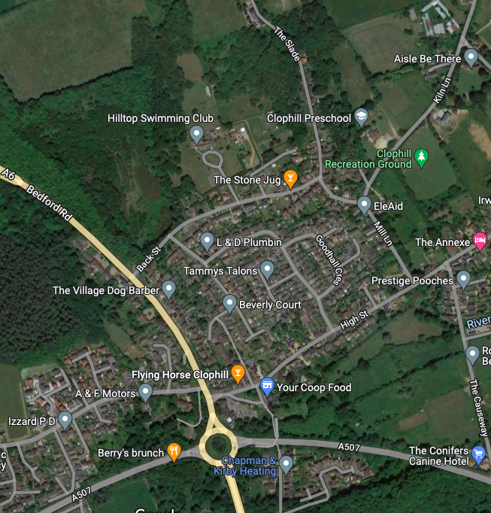
Clophill Archery Club

For further information please see the Clophill Archery Club web site: www.clophillac.co.uk
Or try
what3words Location – target.spells.ignore
ENTRY FORM
32nd Clophill Double WA 720 Weekend (Autumn)
on
Saturday 19th and Sunday 20th September 2026

To be held at Braziers Field, Kiln Lane, Clophill, Bedfordshire
(to the rear of Clophill Village Hall, MK45 4BX)
what3words Location – target.spells.ignore
World Record Status
Field Open 07:00, Registration From 07:45, Assembly 08:30, Practice 08:45 – 09:30, Competition Start 09:30

Please email your completed entry form to outdoor.tournaments@clophillac.co.uk . Please see entry form below for details
Please put “32WA720 Entry 202609” in the subject line! One form per archer please.

Declaration: When signing the entry form you are declaring that you will comply with Archery GB rules on dress, and that you are a paid up member of Archery GB or World Archery. Membership cards MUST be presented upon booking in. Clophill Archery Club (CAC) needs your permission to collect, use and store personal and other data about you in order to carry out its normal competition administration. Your entry to this event indicates that you consent to this.

Archer’s First and Last Name
(For target/result list and sheets)
Archery GB Number
Club Name
Which Day(s) would you like to shoot  (Delete options not applicable) | Saturday only (£25.00 – double round – 1 day) | Sunday only (£25.00 – double round – 1 day) |  | Saturday and Sunday (£50.00 – double round – 2 days)
Bow Type | Recurve / Compound / Barebow / Longbow
Gender/Classification | Open / Female | Left or Right-Handed | Left / Right
Archer Age Category | Cadet (Under 18) / Junior (18-20)/ Senior (21 - 49) / Master (50+ )  U18 DoB DD/MM/YYYY
Shoot as Category | Cadet (Under 18) / Junior (18-20)/ Senior (21 - 49) / Master (50+ )
Do you need to remain on the shooting line? | No / Yes - Wheelchair / Yes - Other
Lunch (Optional) | Chilli & Rice / Cottage Pie / Vegetarian Chilli (Information only pay on the day)
Bank Ref on your Payment | e.g. 31DWA720 SMITH
Your email address
Your mobile phone number
U18 Archer – Parent/Guardian signature for U18 drug testing
Your Signature

