For Sale
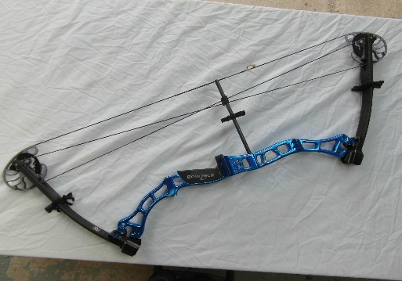

Bowtech Old Glory. Nice condition. A few marks where the sight block and arrow rest have been fitted. Also where the colour has worn off.

Brace Height 8. Axle to Axle Length 36.75. Draw Length 28 " - 32 "
Draw weight 40-70lbs. IBO Speed 300 fps. Mass Weight 4.3lbs.

Price £150.00 ono

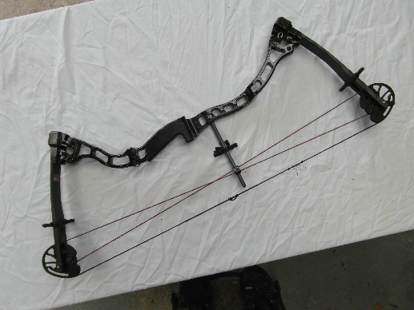
Bowtech Equalizer. Very nice condition. A few marks where the limb pockets have been adjusted.

Brace height 7.25”. Axle to axle 33.25”. Draw length 24-27.5”.
Draw Weight 19-60 lbs. IBO Speed 300-308 fps. Mass weight 3.7 lbs

Price £140.00 ono

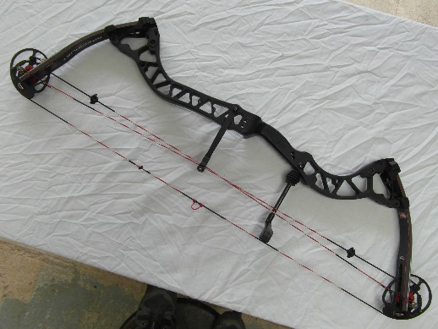
Bowtech Specialist. Exceptionally nice condition. Limbs are in good condition, with only minimal marking to the decorative covering of the bottom limb from the bow stand.

Brace Height 7.5 ". Axle to Axle Length 37.5 ". Draw Length 26-30.5 "
Draw Weight 45-60 lbs. IBO Speed 330 fps. Mass Weight 4.1 lbs
Let-Off 75% or 65%

Price £180.00 ono

With any of the above bows I would be prepared to set the bow up for draw length and draw weight to suit the purchaser. I could also fit their own accessories (arrow rest. Sight etc)

I have several sights and arrow rests for sale. Just ask.

Contact Terry Course 07968668612 topcat2@talk21.com

